**HTML Links**

**What is Link:**

**Write the definition of links!**

**Example:**

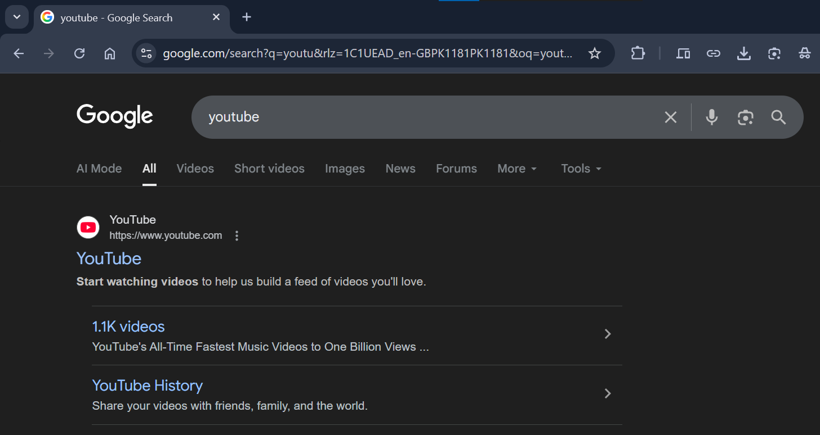

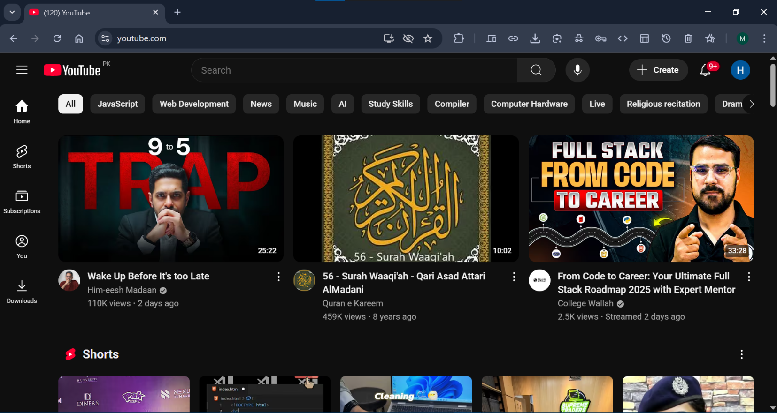

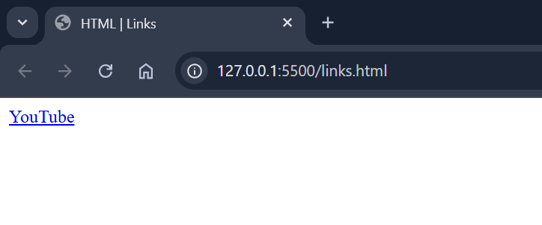

Links are found in nearly all web pages.

Links allow users to click their way from page to page.

**HTML Links – Hyperlinks:**

HTML links are hyperlinks.

You can click on a link and jump to another document.

When you move the mouse over a link, the mouse arrow will turn into a little hand.

**Note:** A link does not have to be text. A link can be an image or any other HTML element!

**HTML Links - The Anchor Tag:**

**Define anchor tag!**

The HTML <a> tag defines a hyperlink.

**HTML Links – Syntax of Anchor Tag:**

It has the following syntax:

**Syntax of the image here!**



The link text is the part that will be visible to the reader.

Clicking on the link text, will send the reader to the specified URL address.

**Attributes Of The <a> Tag:**

There are 3 attributes of anchor tag:

1. href
2. target
3. title

**HTML Links - The href Attribute:**

The most important attribute of the <a> element is the “**href**” attribute, which indicates the link's destination.

**Code:**

This example shows how to create a link of youtube.com and how to specify the URL or link address in the **href** attribute:



**Output:**



**Links Display in Browsers:**

By default, links will appear as follows in all browsers:

* An unvisited link is underlined and blue
* A visited link is underlined and purple
* An active link is underlined and red

**Unvisited Link displays like this:**



**Visited Link displays like this:**

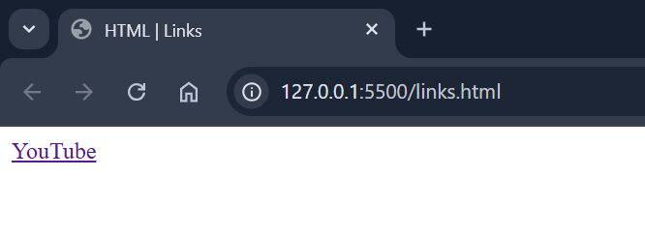

**Active Link displays like this:**

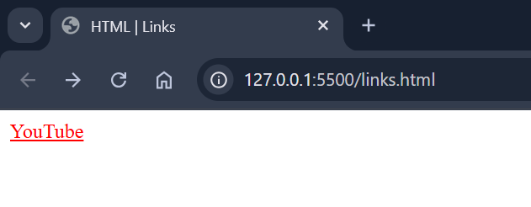

**Tip:** Links can of course be styled with CSS, to get another look!

**HTML Links - The target Attribute:**

By default, the linked page will be opened/displayed in the current browser window.

To change this, you must specify a target for the link.

The target attribute specifies where to open the linked document or webpage.

**Values of target Attribute:**

The target attribute has 4 values:

* _self - Default. Opens the document in the same window/tab as it was clicked
* _blank - Opens the document in a new window or tab
* _parent - Opens the document in the parent frame
* _top - Opens the document in the full body of the window

**Note:** Mostly used “_blank” value of target attribute. Other values are not used so much.

**Code:**

Use target="_blank" to open the linked document in a new browser window or tab:



**Output:**

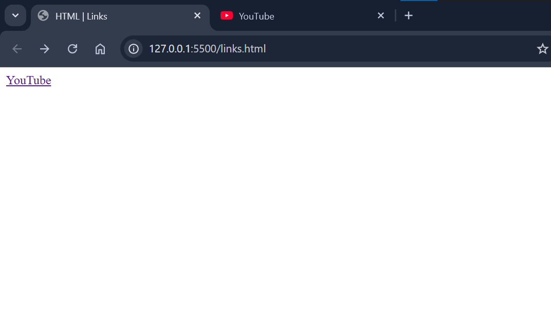

Practice all values of target attribute like above:

**Types of Links/URLs:**

There are 2 types of links or URLs:

1. Absolute URL
2. Relative URL

**Absolute URL:**

Absolute URL is the root/complete address of anything.

It is same in all over the web.

It is permanent address of anything.

Both examples above are using an absolute URL (a full web address) in the href attribute.

**Examples:**

The link of any website is Absolute URL like google, YouTube, Facebook, Instagram, Microsoft etc.

**Code:**



**Relative URL:**

Relative URL is not the root address of anything.

It does not same in all over the web.

It is temporary address of anything.

A local link (a link to a page within the same website) is specified with a relative URL (without the "https://www" part).

**Examples:**

The link of webpages of any website or any media file that is present in any local computer, server or in the internet are relative URLs.

**Code:**



**Output:**

**Before visited the relative link:**

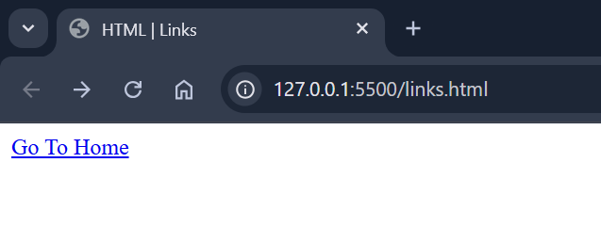

**After visited the relative link:**

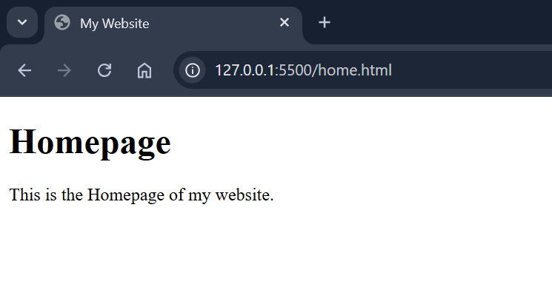

**More on Absolute URLs and Relative URLs:**

**Code:**

Use a full URL to link to a web page:

**Output:**

**Code:**

Link to a page located in the html folder on the current web site:

**Output:**

**Code:**

Link to a page located in the same folder as the current page:

**Output:**

**HTML Links - Use Image as a Link:**

To use an image as a link, just put the <img> tag inside the <a> tag:

**Code:**

**Output:**

**Link to an Email Address:**

Use mailto: inside the href attribute to create a link that opens the user's email program (to let them send a new email):

**Code:**

**Output:**

**Button as a Link:**

To use an HTML button as a link, you have to add some JavaScript code.

JavaScript allows you to specify what happens at certain events, such as a click of a button:

**Code:**

**Output:**

**Link Titles:**

The title attribute specifies extra information about an element. The information is most often shown as a tooltip text when the mouse moves over the element.

**Code:**

**Output:**

**Chapter Summary:**

1. Use the <a> element to define a link
2. Use the href attribute to define the link address
3. Use the target attribute to define where to open the linked document
4. Use the <img> element (inside <a>) to use an image as a link
5. Use the mailto: scheme inside the href attribute to create a link that opens the user's email program

**HTML Link Tags:**

**Images here!**

**Reference:**

<https://www.w3schools.com/tags/tag_a.asp>